Finally the time has come to install my Crystalfontz 634 LCD courtesy of the Bit-Tech brothers. Well, I say install, but I decided to turn it into a desktop display since installing it in my PC would make it very difficult to see. (The PC is under the desk). Plus, it gives me the excuse to do some serious modding.
Here we go… This is the unit as supplied in its drive bay mounting.
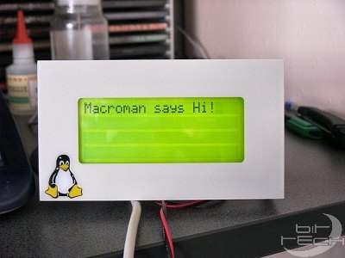
Time for some modding. First the display was removed from the drive bay mounting bracket and then the display bezel removed. Now to “invert” the display. I.E. light characters on a dark background.
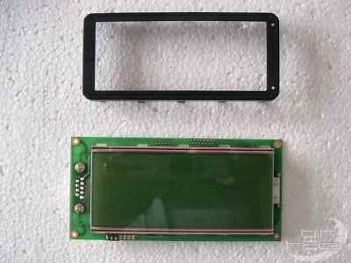
The screen Polaroid sheet was removed by first lifting one corner with a scalpel and then carefully peeled off.
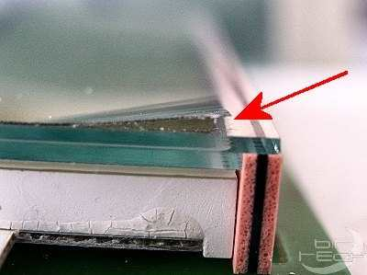
A new piece of Polaroid was cut from a sheet I had lying around, after determining the correct orientation for the effect I wanted. (For those who don’t know, it is the Polaroid sheet and it’s orientation to the LCD screen that determines how the characters are displayed).
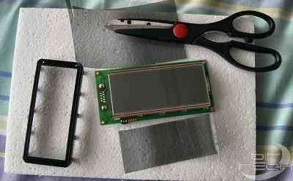
The new Polaroid was laid on the screen and the retaining bezel refitted, sandwiching the Polaroid in place.
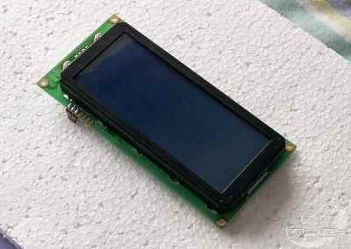
A hole to suit the LCD screen was cut in the lid of the box I was using, and double-sided sticky tape used to attach the LCD to the lid.
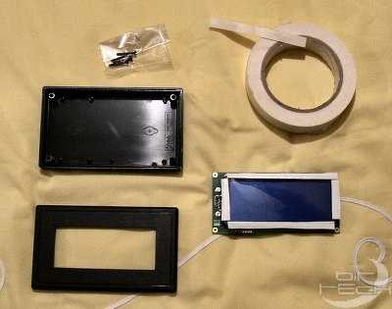
The LCD stuck to the lid. This box is not much bigger than the display itself!
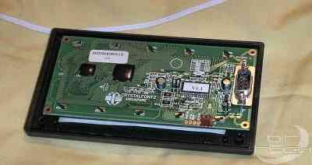
Holes were cut in the back piece of the box for the LCD power and data sockets.
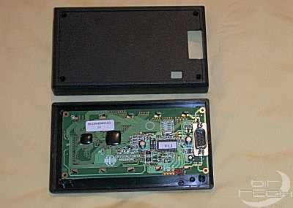
These mounting pillars in the back of the box were cut down so they would help to hold the LCD PCB in place when the box was fitted together. (Just in case the sticky tape ever decides to lose its stickiness”.
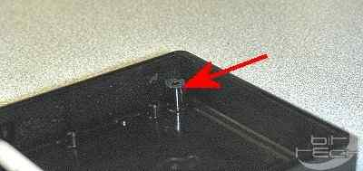
A quick test fit to check it all goes together. So far so good. Now to find a stand to mount the display.
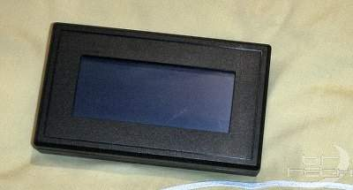
Aha! What have we here? Time to get Creative!
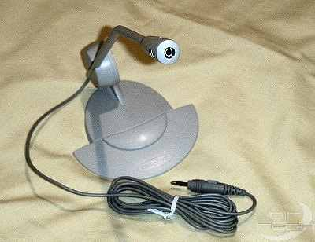
Using my trusty hacksaw, it’s Off with his head!
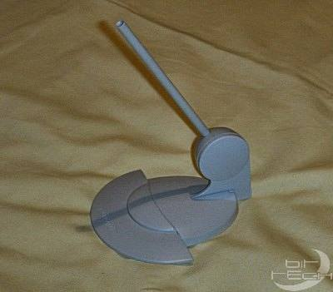
Hole drilled in the bottom of the box to take the (ex)microphone stem.
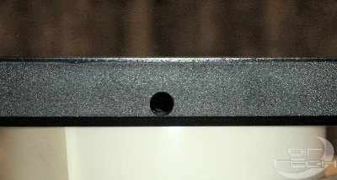
The stem was glued in using modellers “plastic weld”. This stuff literally fuses the plastic together.
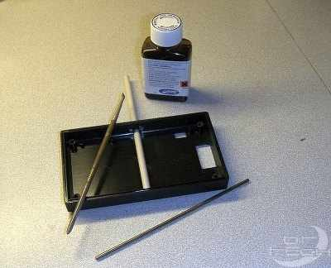
See where I am going with this?
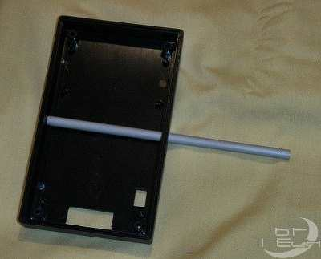
The base looks a bit naff, so lets get Creative some more! I removed the front of the base by cutting along the groove with a hacksaw.
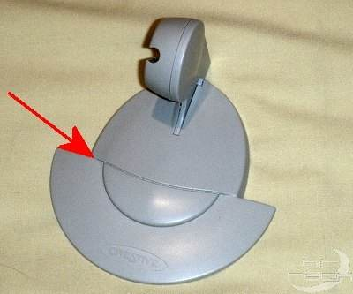
This bit could do with some re-modelling also. I cut of the plastic I didn’t want and then tidied it up with a needle file.
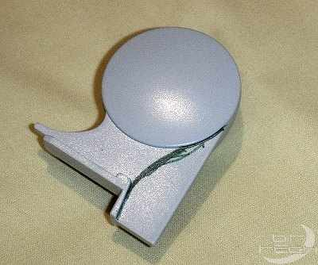
I wanted to put leds in the base but did not want any wires showing so, time for some “macro” surgery I think. I decided to drill a small tunnel right through the base and up the stem to run the wires in.
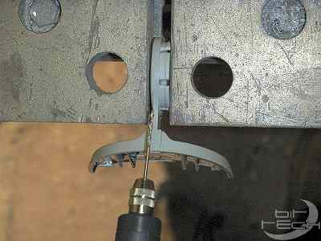
Here you can see the drill showing through the hole. You can see where I managed to graze the side slightly whilst drilling. Soon fix that with some filler and sanding!
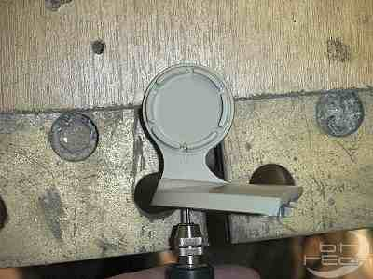
This thing needed a clear base for what I had in mind. So I cut one from an old CD jewel case.
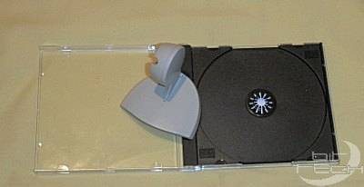
I decided to fill all the cracks and gaps with “Milliput” body filler to make the base unit look more “manufactured”. After the filler had hardened overnight I filed and sanded it into shape.
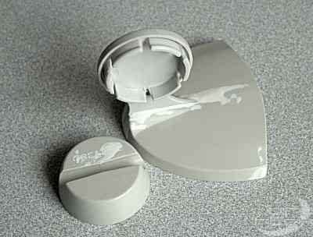
Three more strategically placed holes.
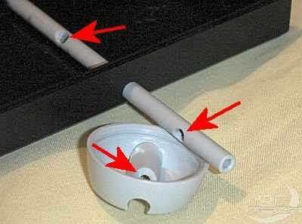
The underside of the base was covered in aluminium tape to reflect the light from the leds, and very fine “wire wrap” wire fed through the hole. Notice the clear base ready for gluing on.
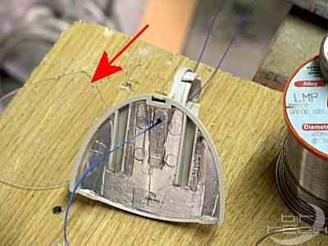
To make the leds lie in the right position they needed filing down flat. I also diffused the ends using 800 wet and dry.
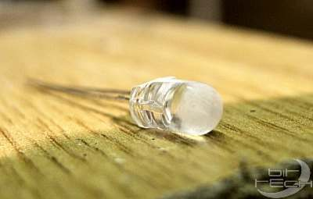
47ohm resistors were soldered to the leds, which were then glued in place with clear epoxy.
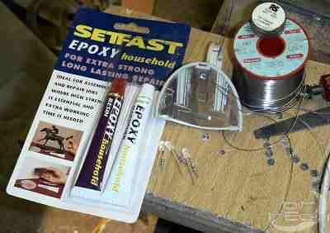
Once the epoxy was set, the led wiring was finished and the clear base glued on using the “plastic weld”. You will notice in this shot that the stand has been sprayed black. I got carried away building this project and forgot to take pics. (Sorry).
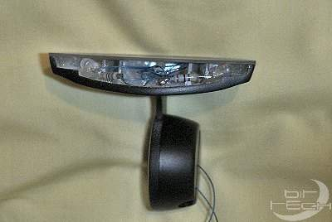
Back to the LCD case for more tweaking. Since this display was going on my desk, I wanted a manual contrast control. So, a quick hole to accommodate the 10K preset needed for the control.
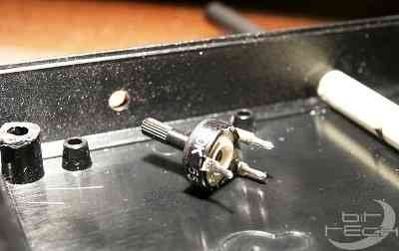
The preset was fixed in place with superglue, being careful not to get any on the shaft!
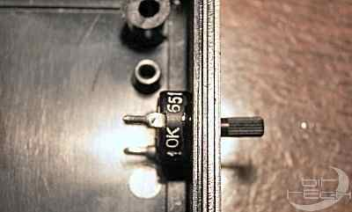
To use a manual contrast control, R8 needs to be removed and the presets wiper connected to the pad indicated. The two other connections on the preset going to 0V and 5V respectively.
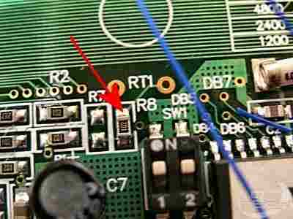
I decided not to remove R8 but just lift it up so I could revert back to software control should I ever want to in the future. (where else would I safely store a component that small?).
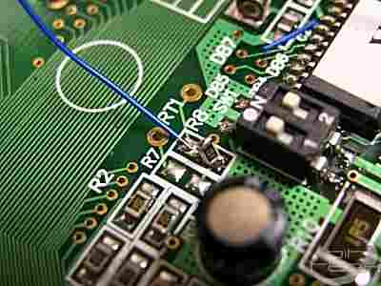
The wiring was completed. Here you can see the wires to the leds coming up from the base, these are soldered directly to the 5V led supply socket. O.K. Time to re-assemble everything and give it a try.
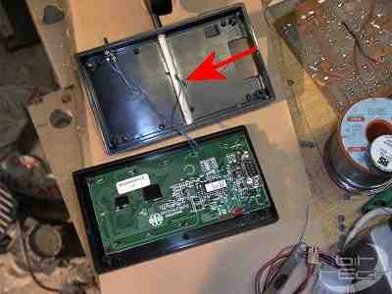
Here it is, the finished unit in all its glory. This is in reflective mode.
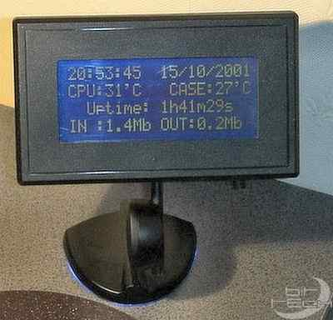
Ooh ooh very blue!
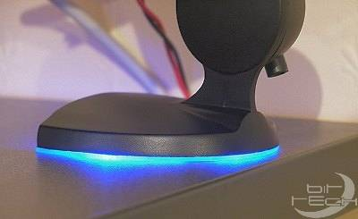
Hmmm…. This is backlit mode.
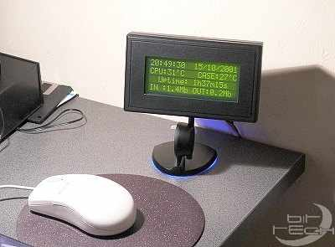
Finally, the beauty shot, as they say in the business. You can just see the manual contrast control on the bottom of the box.
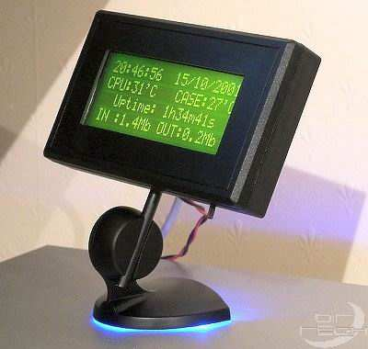
Well, was it worth the effort? I think so, because the display is fully articulated, I can read it from any angle whilst sat at my desk. Plus I think it looks quite cool and stylish. But what do you think? Forums....

